CURRICULUM VITAE

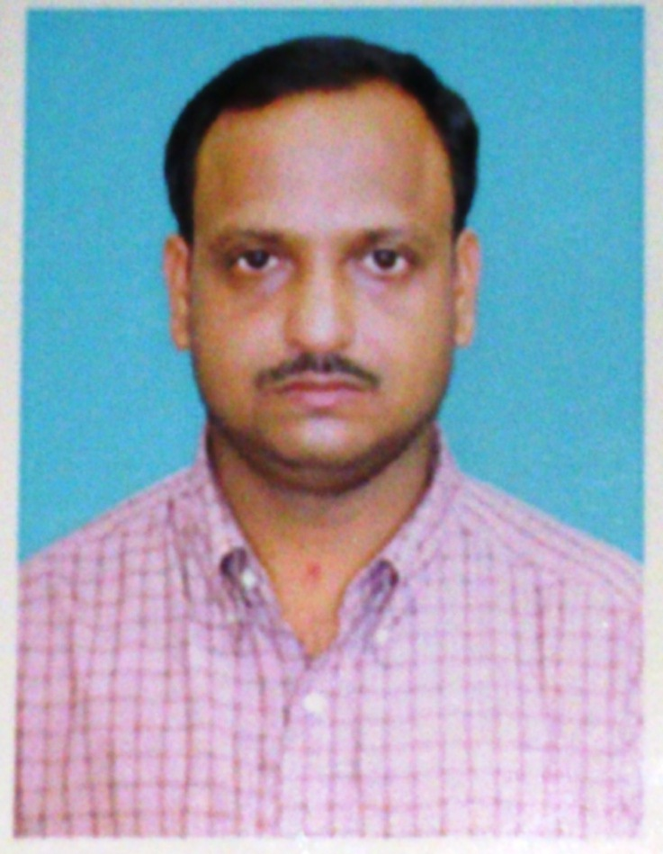
Basanta Kumar Tripathy
At/PO. –Danda mukundapur
Via- Pipli, Dist- Puri
e-mail-bktripathy1975@gmail.com
Mob- 9938249274.

About myself: -
A pragmatic person uses logic and analysis as guiding principle of living. Strong beliefs on human values,
this always influences my action. I am reliable and learn from the reflections of actions. I am sociable and prefer to communicate in writing as well as by talking.
Strength: -
I count my equanimity in times of stress among my major assets. My planning abilities have been further sharpened by my experience in the corporate and development sector and my sensitivity to the issues at the grassroots level. My association with NGOs—both in the financial and program monitoring capacity and as a funding/implementing agency—enables me to negotiate for my organization on terms and modalities of functioning with other organizations at different levels.
Core Competency Skill: -
- Carrying out initial accounting tasks as preparation of voucher, maintenance of book of prime entry as well as subsidiary books.
- Can perform above tasks both manually and with accounting software.
- Perform internal audit and apprise internal control system.
- Maintain records of receivables and payables.
- Handle TDS and GST matters.
- Preparation of submissions of Income Tax assessment.
- Preparation of Bank Reconciliation Statement.
- Preparation of periodical reports as and when needed.
- Dealing with cash and bank transactions.
- Excellent leadership trait with clear perspective to work with partners/clients.
- Team player and with good oral and written communication skills;
- Excellent time management and scheduling skills to achieve the goal;
- Able to handle heavy workload and meet the deadline i.e. time bound goal achievement.
- Good problem solving and negotiation ability.
- Excellent coaching and training abilities.
Working Experience: -
Experiences 15 years in different capacities in both corporate and NGOs.
Articleship-Completed article ship training under the following firms (from Oct. 1994 to Jan. 1998)
K.P. Gutgutia & Co
2, Princep Street, Kolkata.
Roy Chowdhury & Associates
14, BBD Bag Kolkata.

Post-Articleship Experience- (From March - 1998 –Till Date)
Worked with Different Commercials, Non –Profit organizations, Limited companies, Educational institutions, etc. in assistant and managerial status.
Major Audits:-
Statutory Audits:
Lionel Edward Ltd., G.K. Plastic Pvt. Ltd., Make well Pvt. Ltd. Lions Orthopedic Hospital, Lakwa Tea Garden, Sital commercial Pvt. Ltd., Sonali Commercial Pvt. Ltd., Maruti Building, Syndicate Fund, Venu Gopal Stock Holdings, Rajpur firms, Xavier Institute of Management. (XIMB), Orisson Plastics Private Limited, Srikrupalu Steels Private Limited, Air Odisha Aviations Private Limited etc.

Internal Audit:
Oudh sugar Mills Ltd, Bharat Sugar Mills Ltd, Gobind sugar Mills Ltd., Hindustan Motor Ltd. Kusum products Ltd, Orient Paper Mills. Public Sector Undertakings-Mahanadi Coal Fields Limited, Odisha Hydro Power Corporation Limited, Odisha Power Transmission Corporation Limited, CESU, NESCO.

Trusts, Educational Institutions and Others
Young Cricketers Associations, Lion Safari park, Mahesh Tala Girls School, Kamala Girls High school, Regal Cinema, Kalpana Cinema, Kolkata Medical Research Institute.

About Last Assignments: -
SRB Associates
Xavier Institute of Management (XIMB)(November - 2004-December - 2007)
About the organization-, XIMB is a leading intermediary agency availed higher education to professionals and providing financial and technical support to various local NGOs partner to implement different social projects.
Senior auditor-
Key responsibilities
- Planning and implementing audit program.
- Carrying out audit up to finalization.
- Auditing, Preparing receipt & payment accounts of social projects.
- Preparing project reports and Utilization certificates.
- Supervising audit staffs and monitoring their performances.
- Participation in finalization of accounts
- Working out variance analysis i.e. budget vs. actual.
- Dealt with grant in aid of donor agencies associated with social wing of XIMB(CENDERET).

Point person for Social Audit (investment vs. impact)
- Conducted social audit at field on various social projects focusing on water and sanitation, general health, economic empowerment.
- Consulted with Govt. Officials, partner NGOs, PRI members and beneficiary of the community to know the program impact.

KAS Foundation & Jagannatha Financial Services Limited. (January -2007-June2011)
KAS foundation is a national level Micro Finance Institutions working in Orissa Chhattisgarh, AP West Bengal, Maharashtra, Pondicherry and Tamilnadu. Jagannatha Financial Services Limited is a limited company operating in the above states in micro finance sector. Both the companies invested 480 crores in Micro Finance sector.
Manager internal audit (Deputy Manager Accounts)
Key Responsibilities:
Recruitment, Targeting, Planning, Monitoring, fund disbursement, portfolio management and involve in the process of capacity building of SHGs in setting up and running successful small enterprise and business. Assisting CEO in managing the entire Orissa State operation.
Playing key role in branch audit & providing accounting support.
- Supervising the recording of all the transactions originated at branch level in tally software.
- Merging of branch transactions in head office accounts.
- Preparation of Receipt and Payment account of branches.
- Evaluation of Internal audit report and take follow up action.
- Visiting branches to provide accounting support.
- Performing Pre and post - disbursement audit.
- Carrying out portfolio analysis on the basis of internal audit report
- Establish database on pre disbursement economic condition of the community through field research.
- Socio economic study of the families who involved in income generating activities.
- Providing accounting training at branch level.
Dreamspower Real Estate & Marketing Pvt. Ltd(September 2011 - April 2015)
Chief Accountant: -
Dreamspower is a group of companies, operating with Real estate, Infrastructure, Commercial products & Development divisions in Odisha, Chhattisgarh, Gujurat, Andhra Pradesh & Rajasthan with the turnover of Rs.150 crores.
Job Responsibilities: -
- Working as the head of accounts department.
- Creating initial documents like vouchers, maintaining supporting to comply with audit requirements.
- Preparing daily closing for each company & reporting to management.
- Deal with branches & carrying out internal audit of branches in Puri, Bhubaneswar & Cuttack.
- Handling cash & bank transactions independently.
- Holding meeting at branch level to develop or implement new in relation to accounting control over revenue leakage.
- Maintaining receivable & payable records.
- Recording the transactions in Tally software. (Infrastructures Division)
- Providing technical support to management as and when needed.
- Complying with requirements of TDS.
Swosti Group Bhubaneswar (May 2015 - February 2016):
Assistant Manager- Accounts
Job responsibility- Sundry debtor Management
- Responsibility of whole billing system.
- Responsibility of collection through sales team within specified credit period.
- Placing reminders to clients delaying payment.
- Conducting meeting with management fortnightly to discuss status of debtor.
- Suggesting for legal action against non-paying clients.
- Co-ordination with whole group to solve their problem relating to sundry debtor.
- Operating with IDS and Tally accounting package.
- Deal with client to create better business environment.
Asutosh & Associates (August 2016 – March 2019):
Senior Audit Coordinator
Job responsibility
- Overall management of audit system.
- Planning and coordinating with clients regarding audit.
- Audit report verification and finalization.
- Formulating audit program for different clients.
- Manpower management of auditing department.
- Conducting Internal audit & reporting.
- Major Achievement: Playing key-roll in reconstruction of a sick company.
Gram Tarang Employability Services Pvt. Ltd: - (March 2019 onwards)
Manager Finance & Accounts
Job responsibility:
- Payable Management. (Staff settlement & Salary)
- Project account management. (DDU, HSBC, TMF)
- Audit compliance. (DDU, HSBC, TMF)
- Responsible for all the banking issues.
- Responsible for periodic stock audit.
Qualification:-
Academic: B Com. (Hons.)
Professional Qualification.
- C.A Inter.
- Passed group-II of final examination, ICAI.
Computer Skill
- MS Office-2007(Word, Excel, Power Point, Outlook) Tally.
Individual Profile:-
- Nationality: Indian.
- Date of Birth: 15th March 1975
- Language Known: English, Hindi, Odia and Bengali.
- Expected Salary: Negotiable.

Above stated statements are true to best of my knowledge.

Place -Bhubaneswar Signature.
Date - 18.08.2020

